Cloud Computing
UE19CS352
6th Semester, Academic Year 2021-22
Assignment #: 4 - ZooKeeper
Date: 4/4/2022
Name :  SUMUKH RAJU BHAT | SRN :  PES1UG19CS519 | Section :  H

1.jpg:
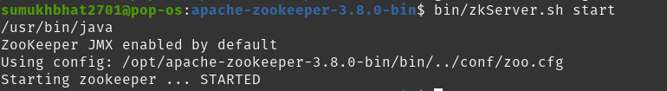
2a.jpg:
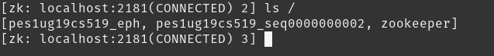

2b.jpg:
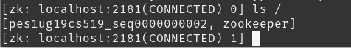

2c.png:
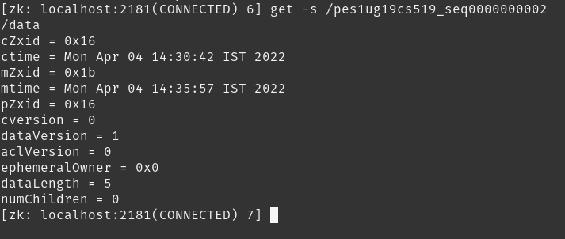

2d.png:
3a.png
Client 1:

Client 2:
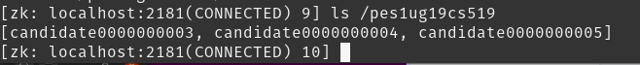

Client 3:

3b.png:
Server:
Client 2: (where the node was “quit”)
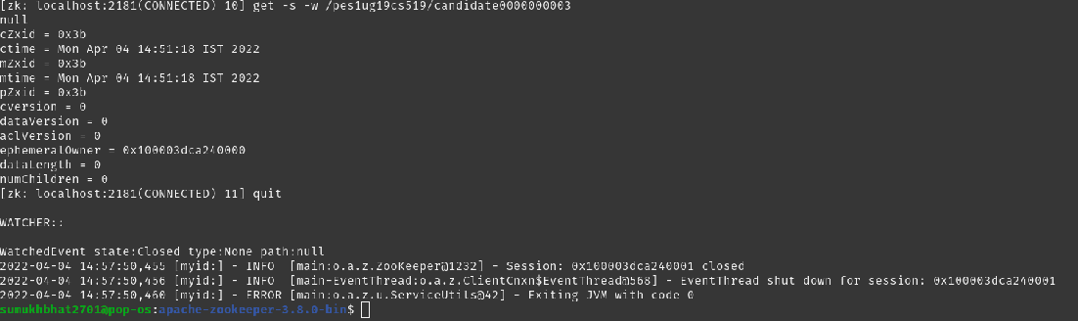
Client 3: (the node upon which watch was kept by client 2)
